Style guide

All screen forms of interface should have the head with a logo (for forms - square variant, for reports - rectangular variant) and the name (except,simple dialogs).

All visual components should be aligned, available, have commensurable scale and don’t leave a lot of free space. Not to allow spelling and grammatical errors.

It is recommended to apply additional colors for different design of even and odd lines.

For texts use black color, or white (if a background - dark); outline: normal, italics or bold; size: 11 - 18.

All elements of the interface should be logically grouped together to make the system simpler in use.

In the system identical design should be applied.

Any visual element includes screen forms, reports, texts etc. contacts belongs to appearance.

**Colors**

Main

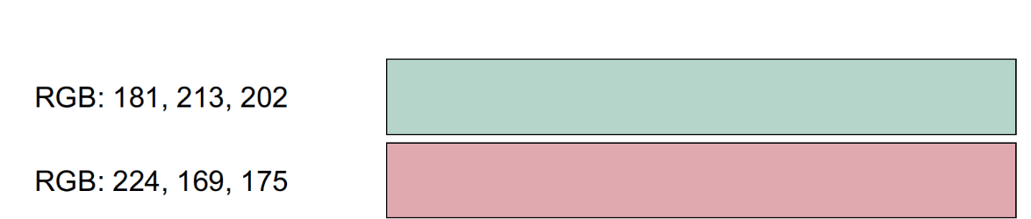

Additional

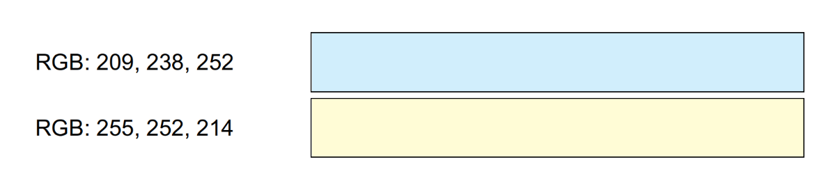

For texts

